ANEXO

Datos solicitados para el abstracT (Fecha límite 31 de enero)
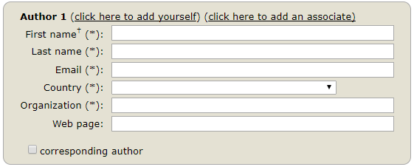
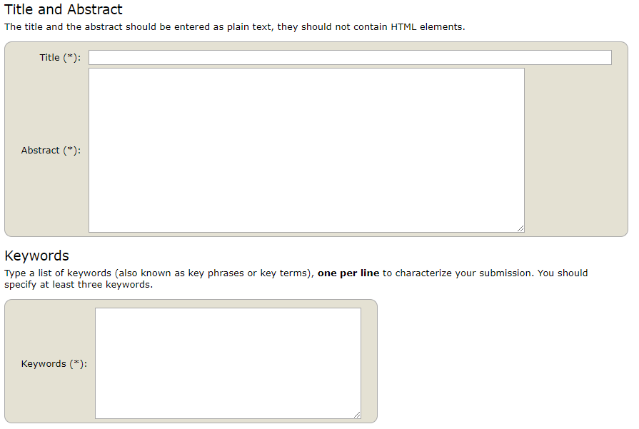

Datos solicitados para el ARTICULO IN EXTENSO

Si el abstract es aceptado (la notificación se te hará a más tardar el 7 de febrero) tendrás hasta el 28 de febrero para someter el artículo en extenso mediante un archivo en formato pdf con el siguiente contenido:

Proposal TITLE
Author Name¹, Author Name²
¹Author Affiliation, institution, country, email
²Author Affiliation, institution, country, email

theme of proposal, rationale and format of contribution
- Choose one of the themes of the conference.
- Indicate the rationale of the proposal justifying why it fits the chosen conference topic.
- Indicate the format of the contribution: paper, poster, recorded presentation, workshop, hands-on session, thematic debate or other type of working session. If it is a group session, provide details about other persons involved.

Description of proposal
The text of the proposal should be between 300 words and 2000 words and should cover the following sections:
- Introduction to the proposal.
- Objectives of proposal.
- Work methodology.
- Conclusions/results.

Other relevant information
Indicate, if necessary, other information that may contribute to the value of the proposed contribution.

TExt Guidelines
All the text must be in one column and Arial font with single-spaced 10-point interline spacing.

5 REFERENCES (only if necessary to justify your proposal or abstract)
- Reference
- Einstein, A. (1916). General Theory of Relativity. Annalen der Physik 49(7), pp. 769-822.

